S3
Adonay Tesfamichael
IT-214-DL3
This SQL assignment shows a leagues database. Which stores SEASON, CLUB, TEAM, DIVISION and REGISTERED.
Task 1-ERD Model
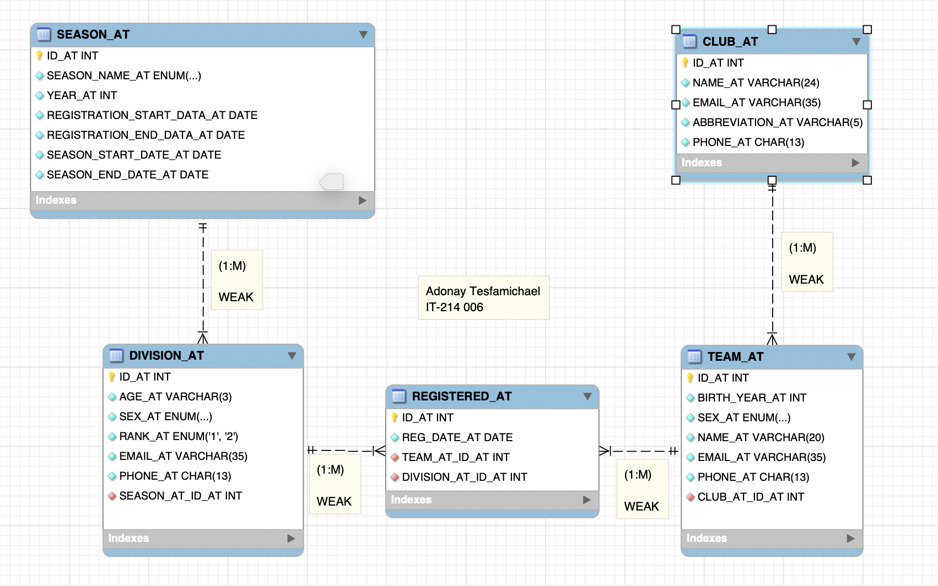
SEASON
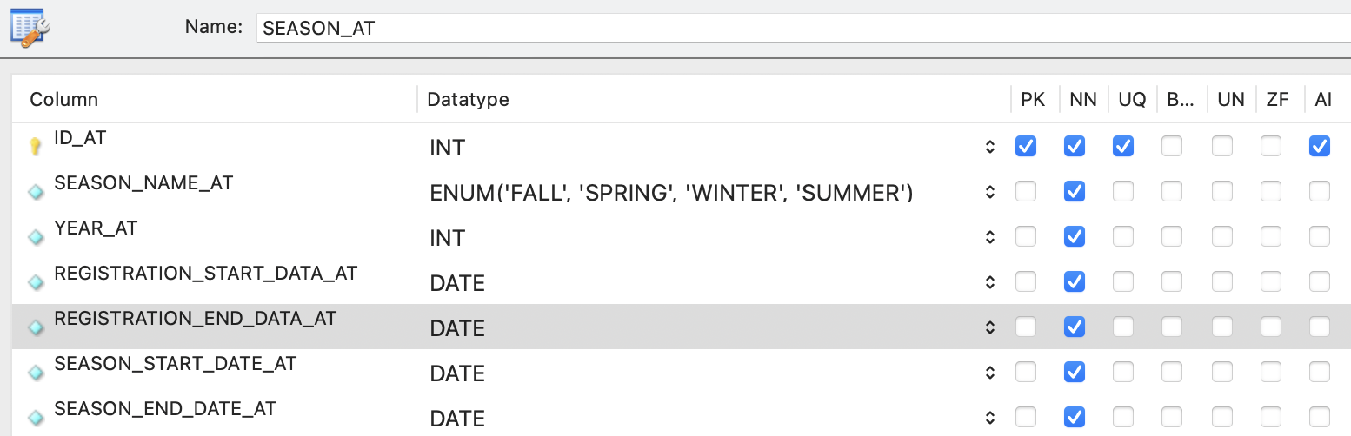
DIVISION
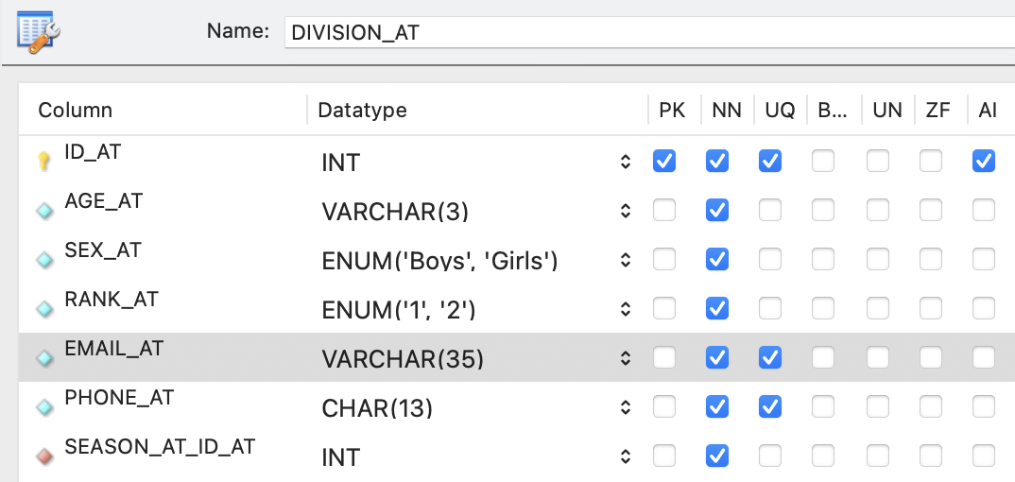
TEAM
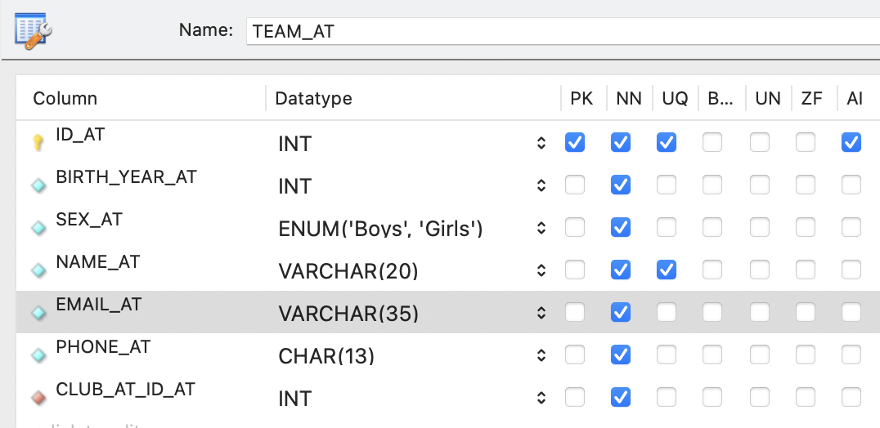
CLUB
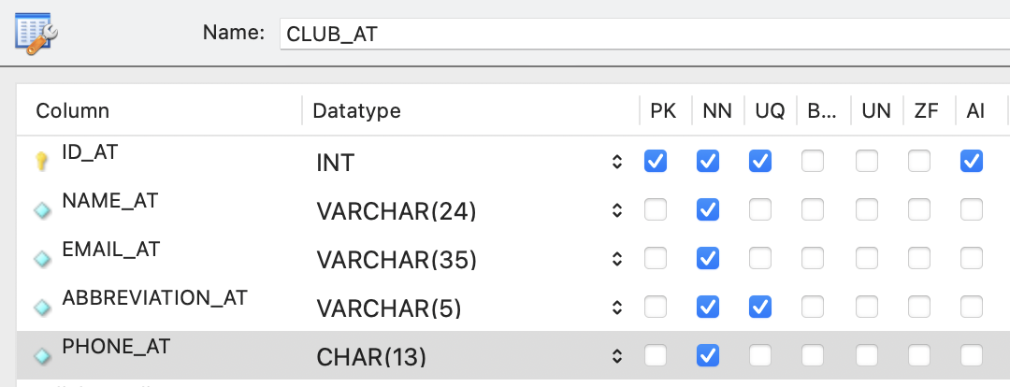
REGISTERED
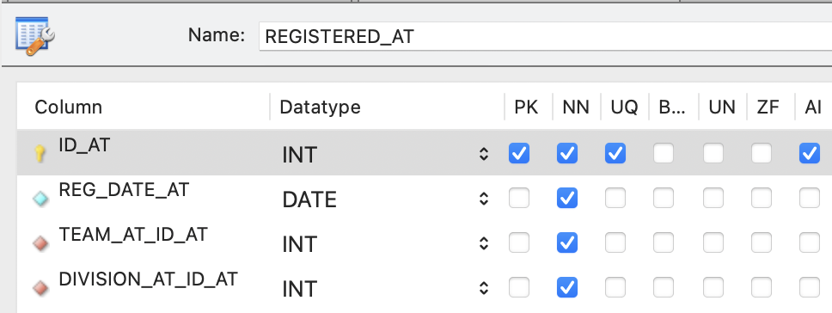
-- Task 2 Create database by Adonay Tesfamichael
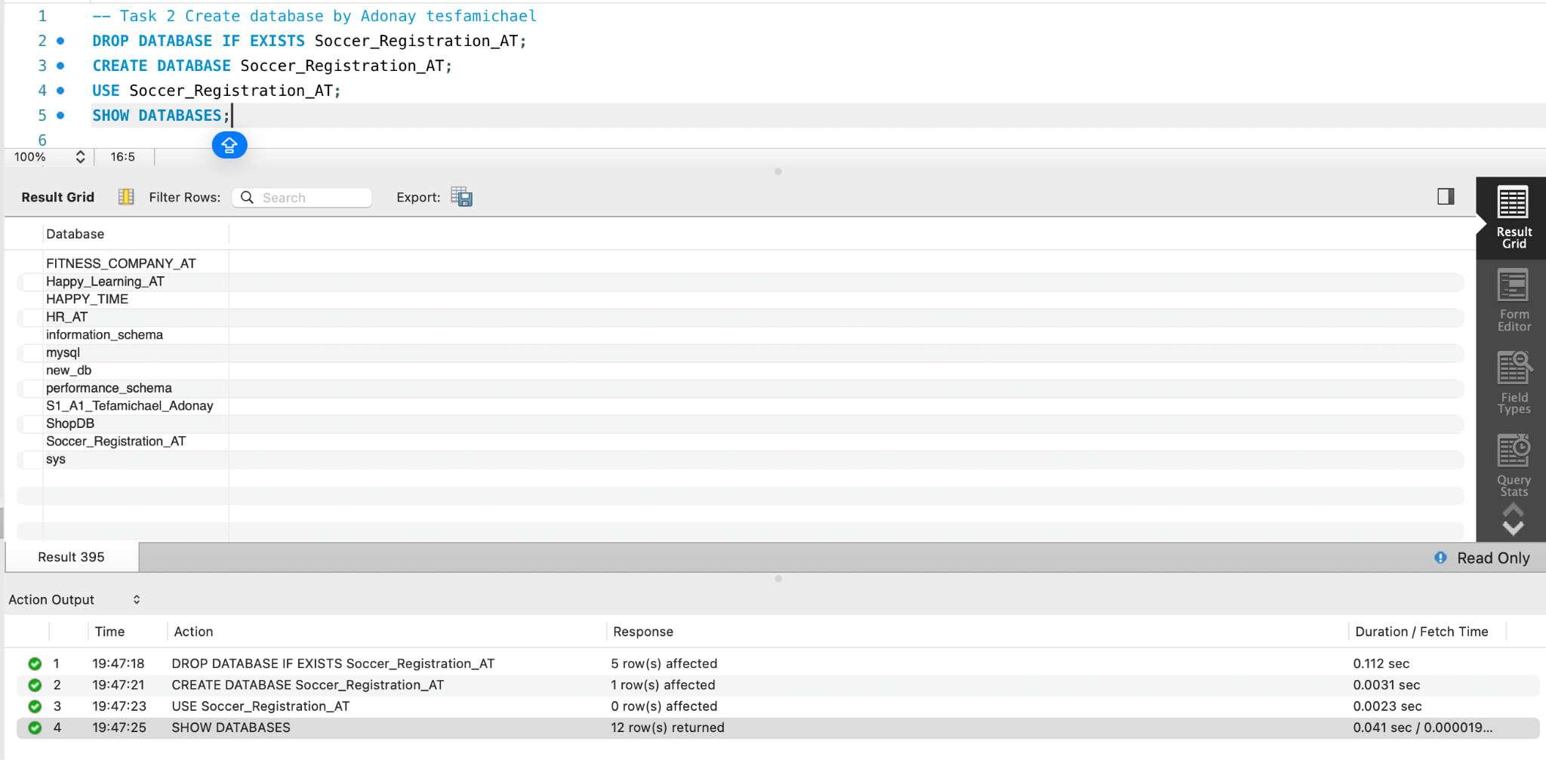
-- Task 3 - Create table by Adonay Tesfamichael
SEASON-
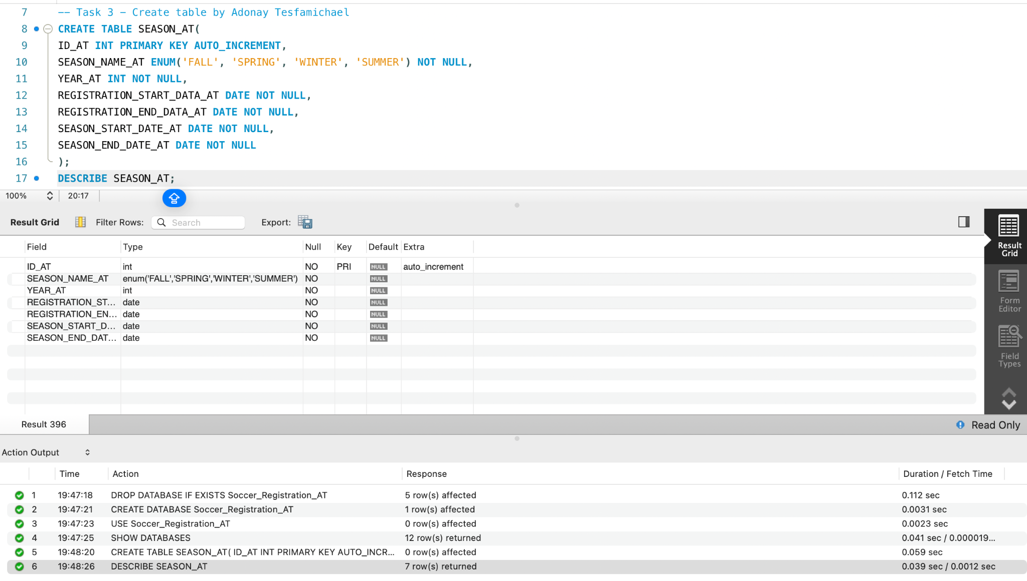
DIVISION-
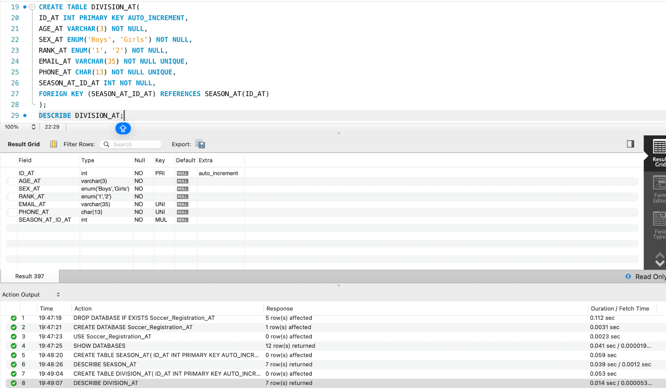
CLUB-

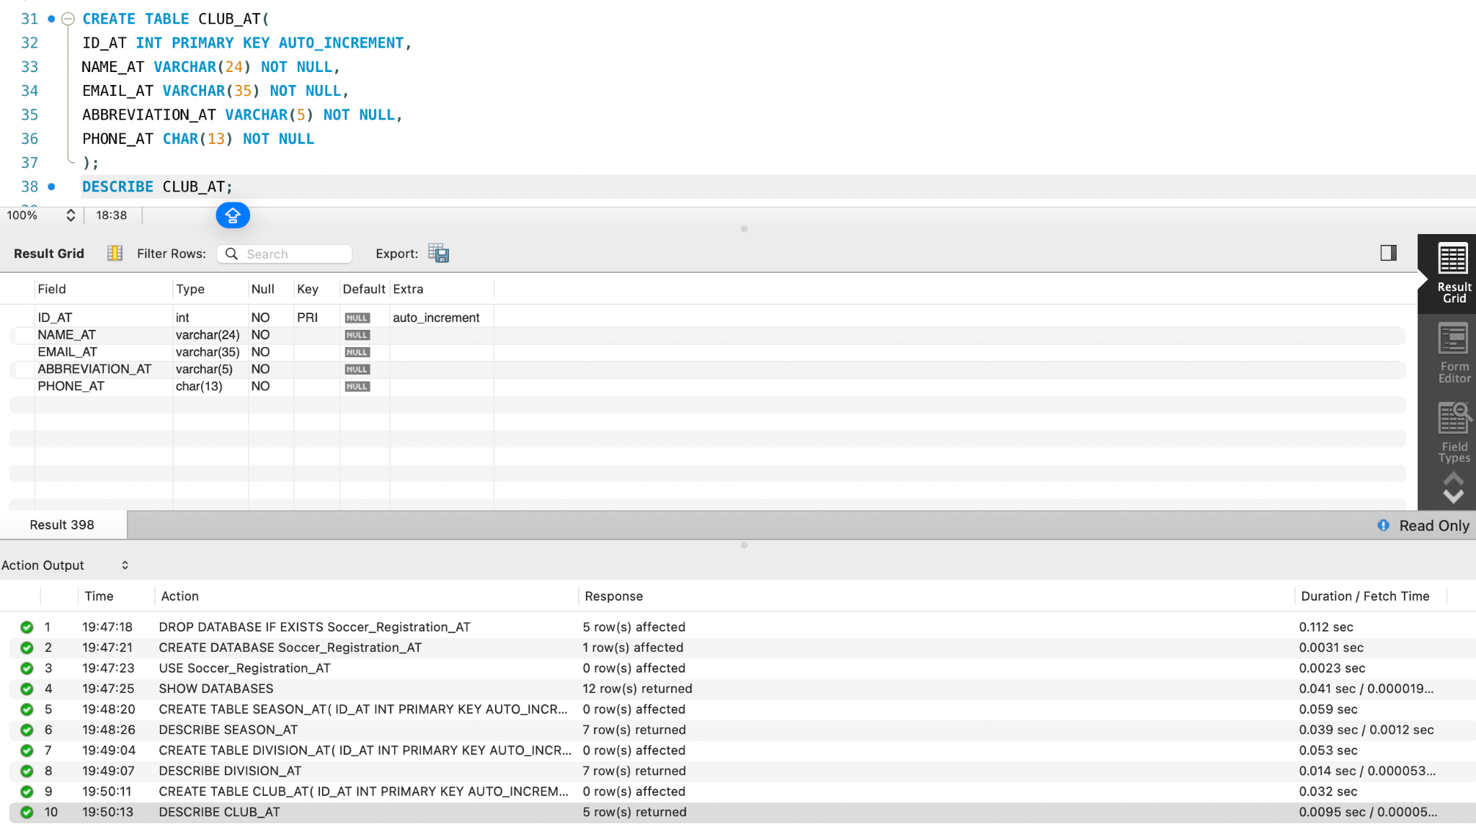

TEAM-
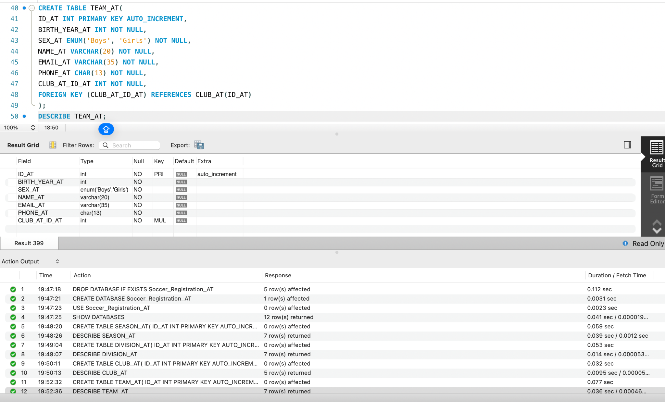
REGISTERED-
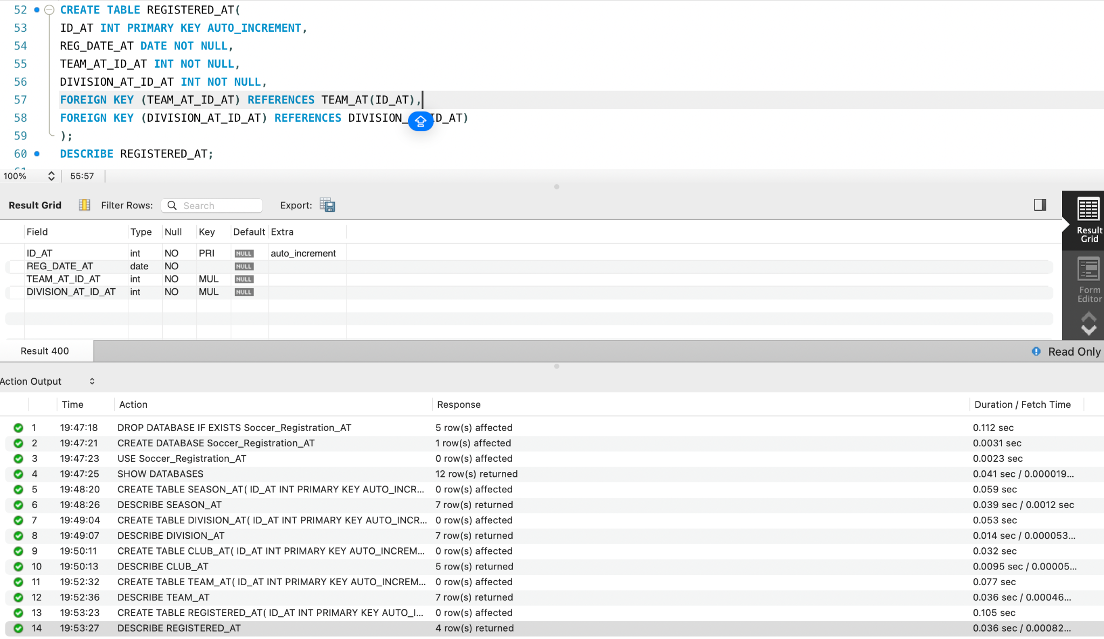

TABLES CREATED
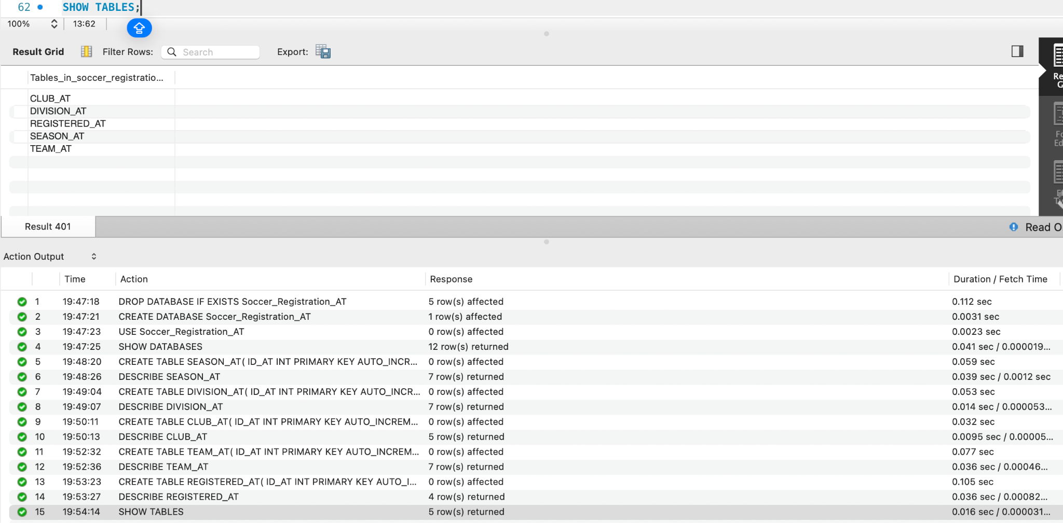

-- Task 4 - Add data by Adonay Tesfamichael

SEASON-
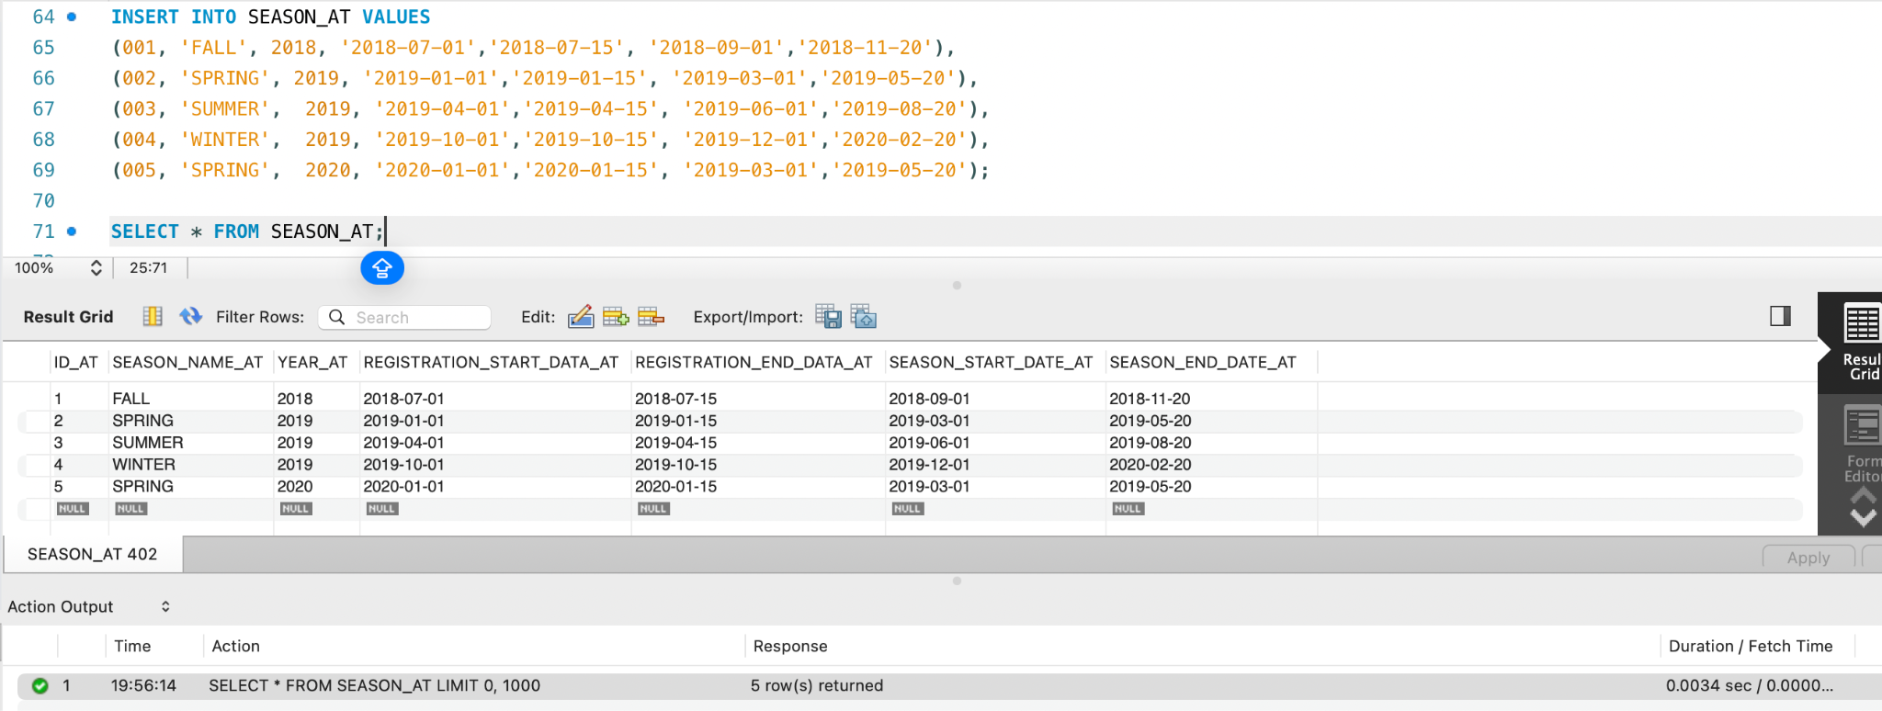

DIVISION-
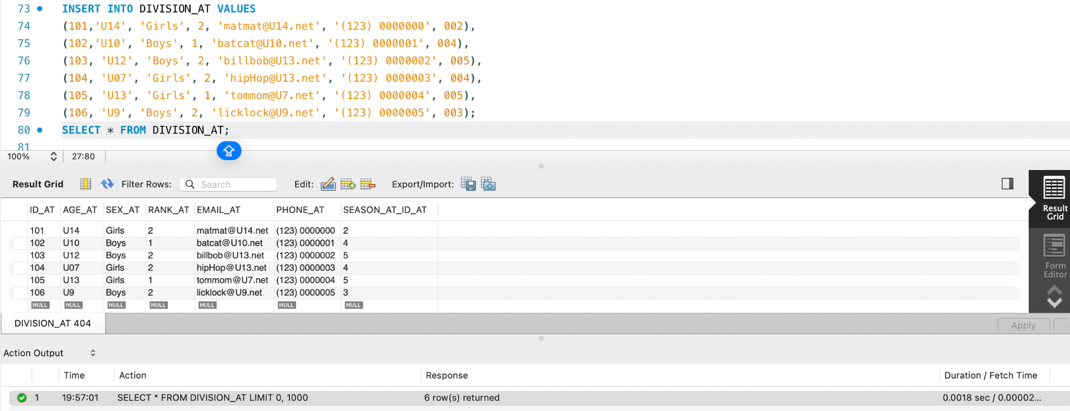

CLUB-
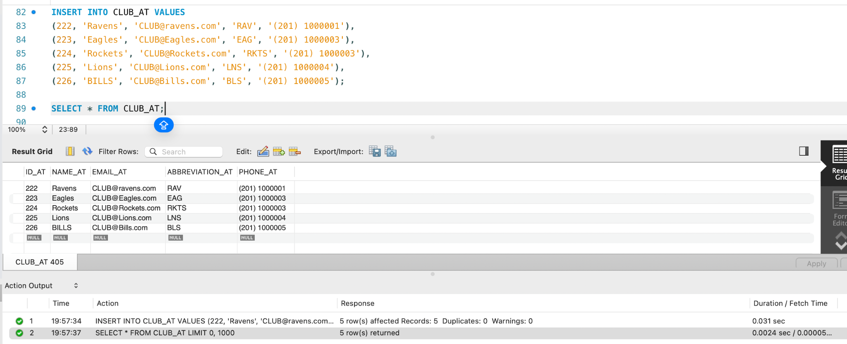

TEAMS-
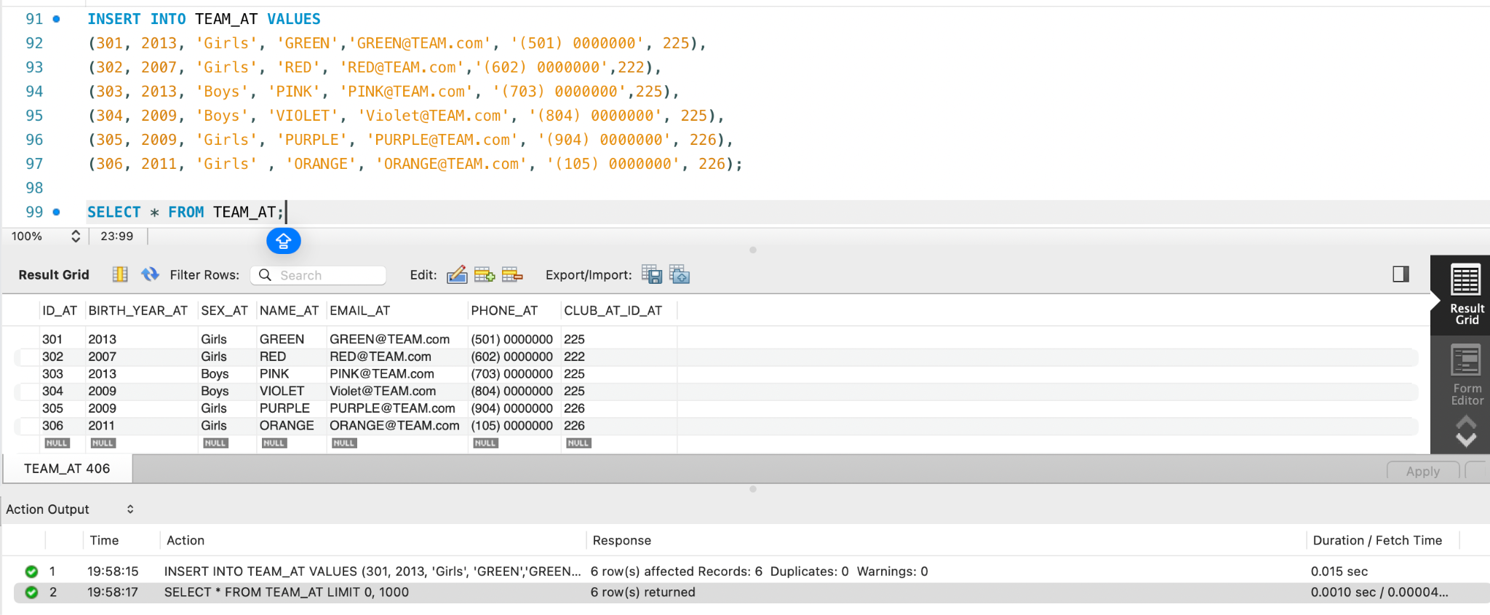

REGISTERED-
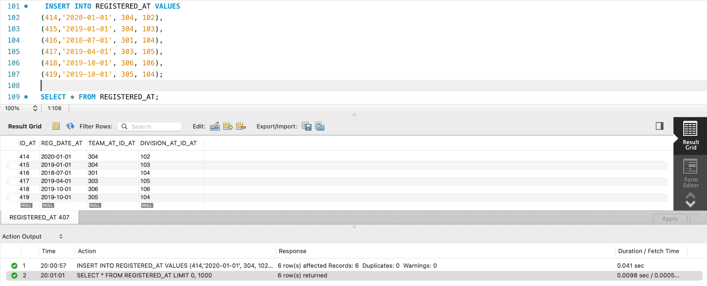

- List alphabetically all the names (with the header name) and the sex of the players (with the header player) for the teams that are enrolled in the "Winter 2019" season (you do not know the ID).
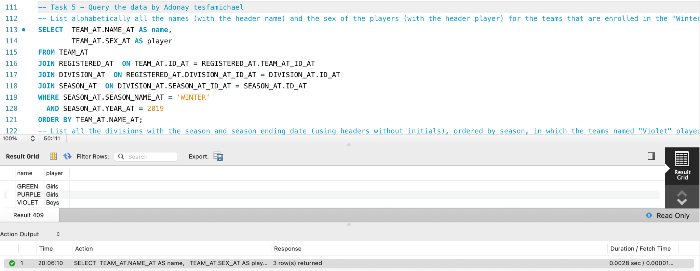
- List all the divisions with the season and season ending date (using headers without initials), ordered by season, in which the teams named "Violet" played.
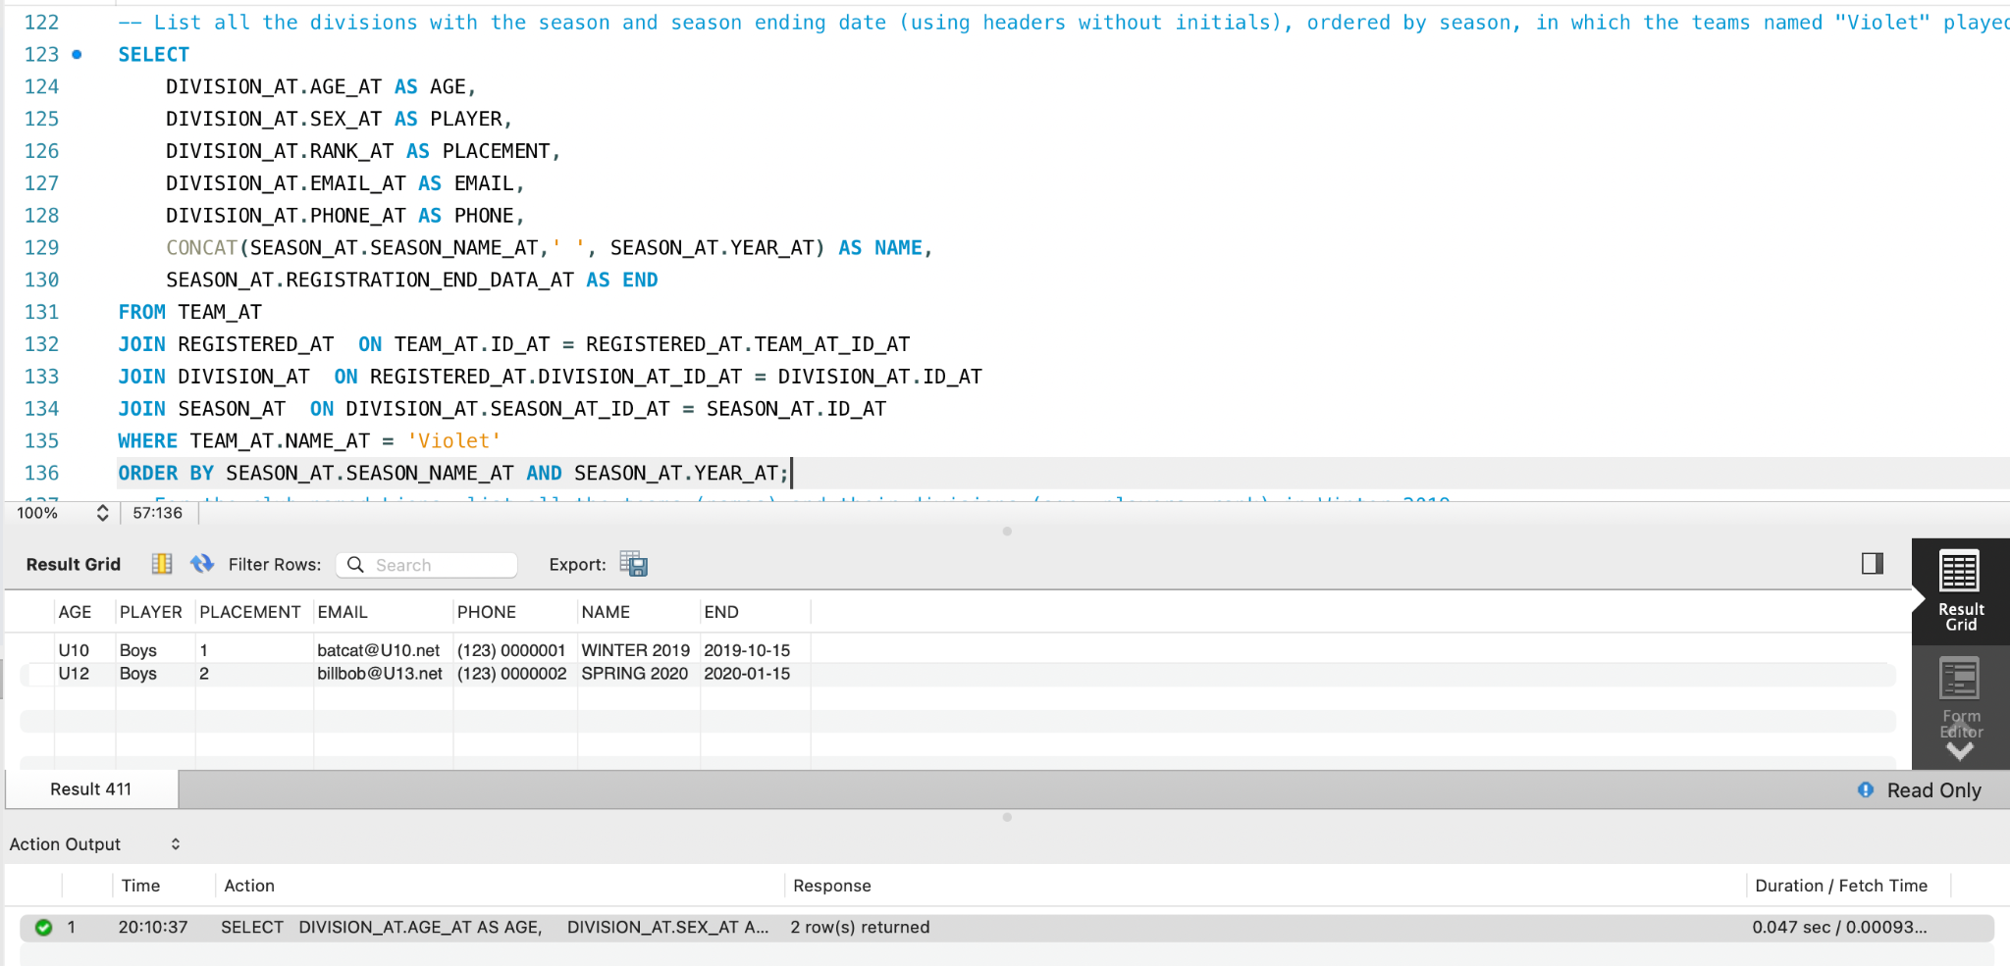
- For the club named Lions, list all the teams (names) and their divisions (age, players, rank) in Winter 2019.
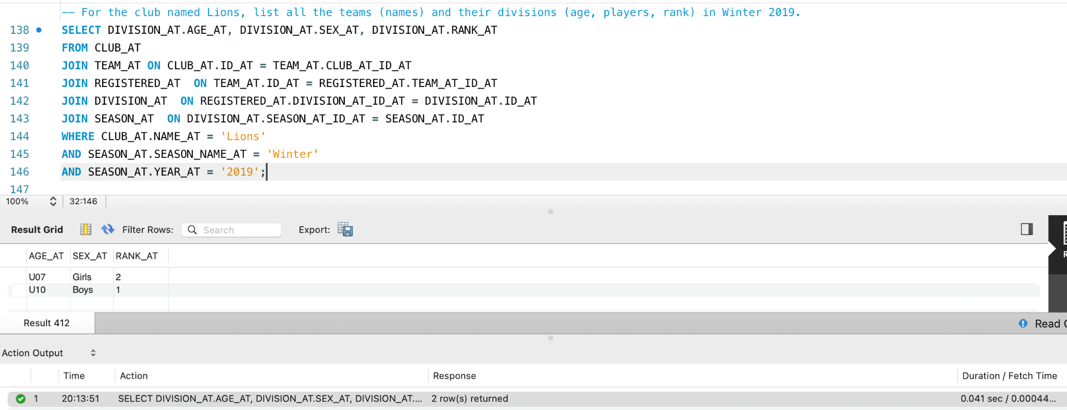
- For all the divisions in Winter 2019 that are under 10 or younger, list the teams names, clubs names and the year of birth for the players using nice headers.
